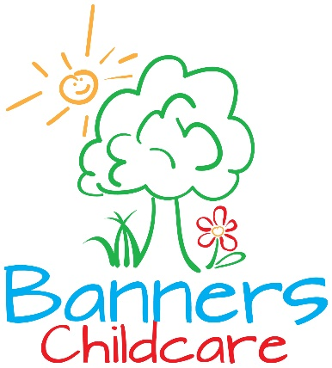
Ph: (585) 427-0700, Fax: (585) 427-0672
Parent Handbook Acknowledgment Form
I have read the Banners Childcare Parent Handbook and I understand the policies stated in it.
___________________________________________________
Parent/Guardian Name (printed)
____________________________________ ______________
Parent/Guardian Signature Date

